

**Standard Operating Procedures**

**Basic Infantry**

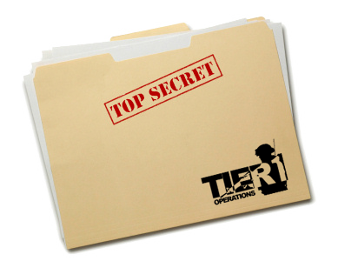

Contents

[1. Basic Infantry 3](#_Toc366678526)

[A. Fireteam Members 3](#_Toc366678527)

[B. Formations and Sectors 3](#_Toc366678528)

[C. Basic Infantry Range 7](#_Toc366678529)

[D. AT Range 8](#_Toc366678530)

[E. Grenade Range 9](#_Toc366678531)

[F. Communications 9](#_Toc366678532)

[G. Medical Emergencies 10](#_Toc366678533)

# Basic Infantry

This section will mostly cover you as an individual soldier and your gear. It will also explain the basics of the medical system, radio operations and fireteam formations.

## Fireteam Members

The smallest unit in the Tier 1 platoon is the Fireteam. Each fireteam consists of 4 members, who each have a number, specific task and position within the team.

1. The Fireteam Leader (FTL) C:\Users\Arnout\Pictures\Inkscape\ArmA 3 Unit Marker TL_S.png  
   He leads the rest of the team, decides which formation to use, has binoculars and an underbarrel grenade launcher. Most experienced member of the team.
2. The Automatic Rifleman (AR) C:\Users\Arnout\Pictures\Inkscape\ArmA 3 Unit Marker AR_S.png  
   He carries the Automatic rifle, basically a light machine gun. He has the most firepower in the team.
3. The Assistant Automatic Rifleman (AAR) C:\Users\Arnout\Pictures\Inkscape\ArmA 3 Unit Marker Basic_S.png  
   He carries extra ammo for the AR and has a rifle with a medium range optic, to help the AR with spotting targets and hitting them at longer ranges.
4. The Rifleman AT (RAT)C:\Users\Arnout\Pictures\Inkscape\ArmA 3 Unit Marker RAT_S.png  
   Junior member of the team, carries the AT launcher if it is available.

Every fireteam consists of two buddy teams. Buddy team red and buddy team blue.  
Team Red: FTL and RAT (nr. 1 and nr. 4)  
Team Blue: AR and AAR (nr. 2 and nr. 3)

You should always keep an eye on your buddy. If he gets shot, it is your job to inform the FTL and drag your buddy to safety and stabilize him. (See 'G. Medical Emergencies').

These numbers also indicate the chain of command within the fireteam. Should the fireteam lead (nr. 1) die, the automatic rifleman (nr. 2) will take over, etc.

## Formations and Sectors

The fireteam is able to form 3 basic formations. In each formation, every fireteam member has a fixed position and a sector to cover. While the fireteam moves you should keep an eye on this sector and when the fireteam halts, you should turn towards your sector and cover it.

Within a fireteam each member is responsible for covering a sector. Each fireteam has 4 sectors: front, right, left and rear. These depend on the direction of movement. Front is always the last direction that the fireteam was moving in.

Our fireteam numbering makes it easy to remember which area should be covered by each member.

1. FTL: Covers front
2. AR: Covers right
3. AAR: Covers left
4. RAT: Covers rear

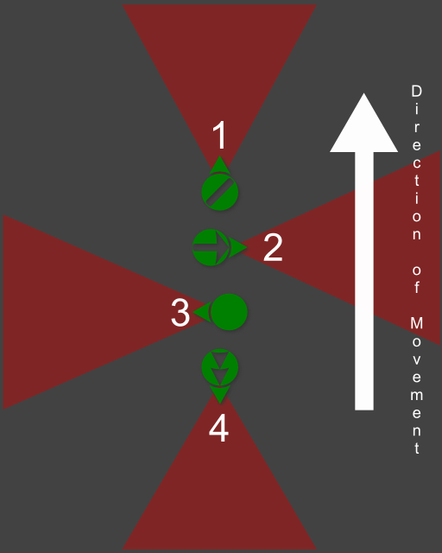Column formation  
Use: when marching through safe areas or in urban areas with little room to maneuver.

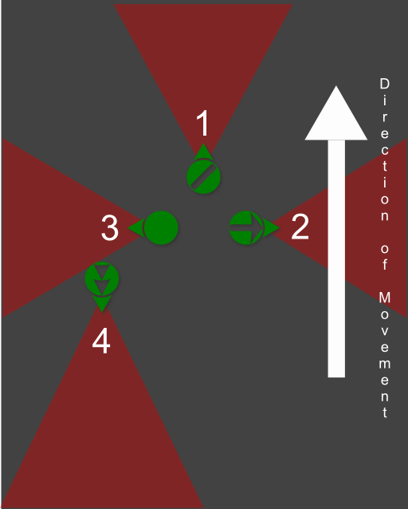Wedge Formation  
Use: in the open when enemy contact is likely. Note that the Rifleman (RAT) nr. 4, can either be on the left or right side of this formation. This depends on the terrain.

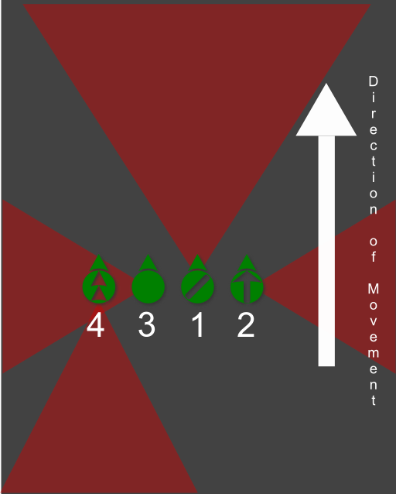Line Formation  
Use: when assaulting enemy positions, mostly used for the base of fire elements.  
Note: When in line most units will focus towards the front, however you are still theoretically supposed to check your sector. It seems wrong in the line formation, however we maintain the same sectors for each unit to make it easier to remember.  
Note that the Rifleman (RAT) nr. 4, can either be on the left or right side of this formation. This depends on the terrain.

## Basic Infantry Range

The basic infantry range will help you to familiarize yourself with the movement in ArmA 3.

Start at the flag and move from position to position where you will shoot every practice target once.

Positions:

1. Prone firing
2. High stance
3. Leaning around a corner
4. Crouching
5. Moving and shooting

Tip: reload while running from one position to the next.

Note that ArmA 3 features additional stances by pressing the CTRL key together with the WSAD keys.

## AT Range

In every fireteam the RAT carries a PCML. This is a guided rocket launcher that can be used to destroy enemy vehicles or fortifications.

In order to use it effectively some knowledge of the weapon is required.

The PCML is guided, just aim directly at the target, wait for the launcher to lock on and then you are ready to fire. In order to fire at fortifications, use the picture below. In the screenshot below you can see the PCML's sight and the ranges marked on the sights. If you can correctly determine the range to the target, all you need to do is line up the sights correctly and fire.

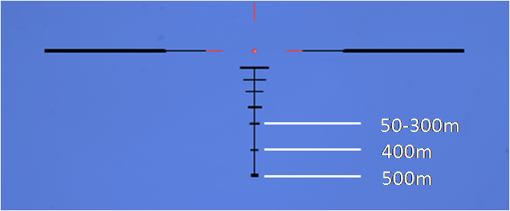

The rifleman will not equip his AT until the teamleader tells him to equip it, this is to prevent any misfires of the AT which can take out an entire fireteam in one shot.

The procedure for firing AT is as follows:  
The teamleader will tell his RAT to prepare the AT and designate the target.  
For example: 'Rifleman prepare AT', 'Target, enemy APC at 230 degrees, range 300 meters'.

The RAT will equip his AT launcher and locate the target. Next he will clear his backblast area. The backblast is basically the overpressure and debris that leaves the rear of the AT launcher when it is fired, so the potential to hit friendlies is large.  
The backblast area is about 25 meters long behind the launcher and consists of about a 30° angle.  
The RAT yells: 'Clear backblast!' and looks over his shoulder to check that there is no one behind him, his buddy will tell him when his backblast is clear. He then announces 'Rocket, Rocket, Rocket!' and launches the missile on the third time he says 'Rocket'.

## Grenade Range

In ArmA 3 the G key allows you to instantly throw a grenade. This can be very useful but also extremely dangerous. You can quickly lob a grenade through a window to take down enemies hiding inside a building. But one press of a button can also cause you to drop a grenade in the middle of your fireteam.

The Tier 1 grenade range is a good way to practice using grenades and get to know their destructive power.

## Communications

Tier 1 makes use of the ACRE mod combined with Teamspeak 3 to make communication in game both easier and more realistic.

Your teamspeak push to talk button will allow you to communicate over direct speech in 3D directional audio with everyone that is close enough to you on the virtual battlefield. Using the ACRE radio button (standard CAPS LOCK) will allow you to talk over your currently selected radio.

Within the fireteam you will almost exclusively use the direct chat and not the radio. The radio will only be used for information that is important for the squad, such as reports on enemy positions, status updates, contact reports, casualties, etc.

#### AN/PRC-343

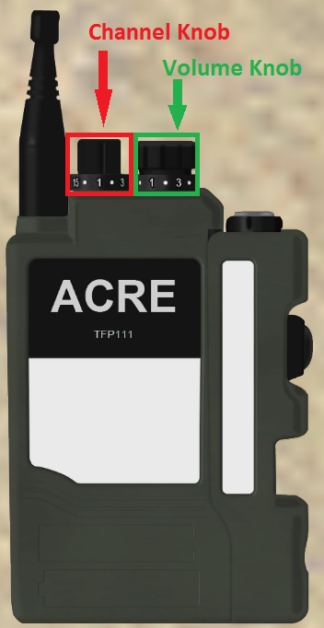Every infantry unit is equipped with at least one radio, the AN/PRC-343.The AN/PRC-343 is a short range radio (about 800 meters range with direct line of sight) for squad level communications. Each squad has a separate radio channel.

1. Alpha squad
2. Bravo squad
3. Charlie squad
4. Platoon attachment
5. Platoon lead

To talk on your currently selected radio you hold down the CAPS LOCK key.  
Note that you cannot hear any incoming transmissions while you are sending yourself.

You open your radio by pressing the CTRL + SHIFT + X key combination. Your radio will open up and there will be two knobs on the top. One changes channels, the other one changes the volume. Left clicking will turn the knob up, right clicking will turn it down.

Pressing CTRL + SHIFT + left, right or up arrow key, will change the current radio to only the left, right or both ears.

Switching radios can be done by pressing the CTRL + SHIFT + A/S keys.

Note that all ACRE radios are affected both by range and the terrain. If you are behind a mountain you will not be able to reach the unit behind it, even when it is within range.

## Medical Emergencies

Someone will get hit eventually, in this case you need to know what to do.

Tier 1 missions make use of a number of custom scripts to augment the medic system in ArmA 3.

If you get hit, you will either be lightly wounded or heavily wounded/unconscious.

If one of your fireteam members gets shot and goes unconscious your first job is to report it to the fireteam leader. Next, check if it is your buddy.

If it is your buddy, pop smoke, try to move his body in a safe position (this can be done by using the **'Drag'** option in the action menu). Then stabilize him (action menu: **'Stabilize'**). Remember that your own safety is always more important than your downed team member. It's better to have 1 man down, than 2 men down.

If it is not your buddy, set up cover for your team members to secure the wounded man. Provide covering fire if necessary. Do NOT stare at the body and anyone stabilizing him, you should be looking for possible threats.

If lightly wounded, and not within immediate danger of dying, wait until the firefight ends and then inform your leader that you need medical assistance. Most of the time, you will have to move to the medic in this case.